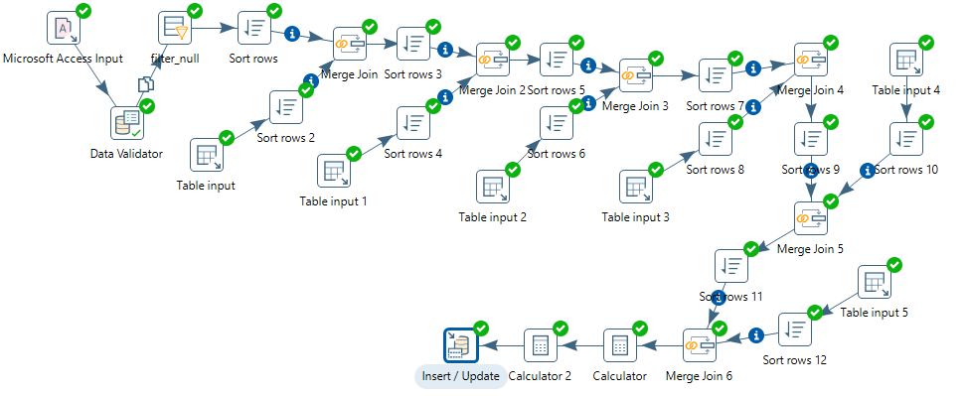

**ETL**

**Add sequence step is not used because the mysql table contains auto increment column**

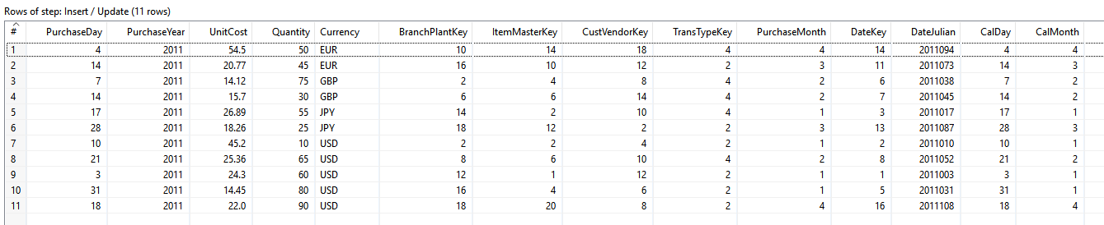

Rows inserted

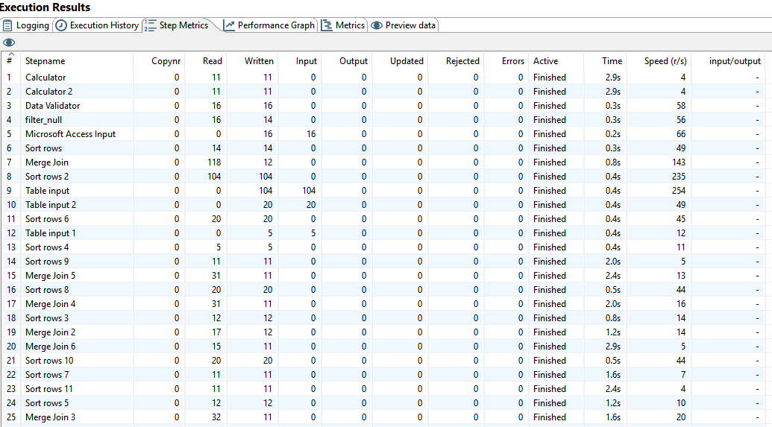

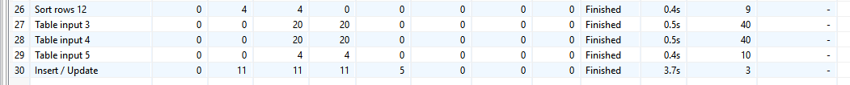

Step metrics